COMP 3008: Assignment #2 User Study

Name: Steven Rhodes

ID: 100819007

URL: https://www.timeanddate.com/

**PART 1: Preparing the Study:**

a) Website Description and Purpose:

Time and Date is a website that is mostly concerned with all things time related. Some of the various options to choose from include: a world clock, time zones, calendars, weather, meeting planners, sun/moon movement, clock timers, calculators, API’s for developers. The site also offers an app for different mobile operating systems. The purpose of the site is to give accurate and precise information pertaining to everything time, weather and more on a global scale.

b) Sample Tasks:

For my tasks I decided to create scenarios where the participants will imagine themselves in specific situations that require them to use the website. I did this because a lot of the tasks you can do on the website are very unidimensional. Having situations allowed me to combine multiple tasks together into one larger task with a purpose and help give the user direction.

**Task #1:**

**Context:**

You have been wanting to travel to Jerusalem and Istanbul (Turkey) for a long time. You have finally gotten some time off and plan to take a break. You can only choose one place and plan to travel from February 22 to February 28th. You will decide which place to choose based on number of sunny days. If one place rains more than the other, then you don’t want to travel there.

Once you have chosen a location to travel, you want to check the time zone of your destination to help determine how much affect jet lag will have on you. Compare this time zone to Ottawa’s time zone.

Next you want to get a printable calendar for your wall, to help remind yourself about your trip. And to be safe you also want to download the site app to give you updates.

You need to:

1. Check weather in Jerusalem.
2. Check weather in Istanbul.
3. Pick which place to travel based on weather during Feb 22-28
4. Check the time zone of this place.
5. Check Ottawa time zone. Compare the two. How far ahead of behind is Jerusalem/Istanbul compared to Ottawa?
6. Find a printable calendar and download it.
7. Get the app for whichever mobile OS you have.

**Task #2:**

**Context:**

You are planning a business meeting in Tokyo. Your clients from Tokyo want a meeting 32 business days from now. You need to schedule the meeting and add it your calendar.

You need to:

1. Your meeting is 32 business days away. Figure out which date this is.
2. Use the website to set up the meeting. Choose the location and date and add it to your calendar.
3. Check the current time in Tokyo.
4. Check the weather in Tokyo.
5. Print a calendar again just in case.

c) Survey:

Below is the survey/ questionnaire I devised for my participants. I tried to collect data and ask questions that pertained to usability. I also tried to mix up the question style using true or false, open-ended questions, and Likert scales.

Questionnaire

Q1: How clear was it to complete task #1?

Unclear Clear

1 2 3 4 5

Q2: How clear was it to complete task #2?

Unclear Clear

1 2 3 4 5

Q3: If you need to perform similar tasks (travel, time zone, weather check), can you see yourself using this website again?

Yes or no.

Q4: Were there any words/phrases/icons that helped you understand what the website was about?

List the items.

Q5: Would you say the layout and design was minimalistic?

Non-mini. Minimalistic

1 2 3 4 5

Q6: If you felt unsure of what to do, was there any help or advice offered by the website?

Yes or no.

Q7: Is there anything that you would change about the layout or the design of the website?

Open answer. Write an explanation.

Q8: How satisfied were you with using the website?

Unsatisfied Satisfied

1 2 3 4 5

Q9: On a scale of 1 to 10, how would you rate your technical skills?

d) Setting up the study:

In-person or remotely: The experiments will each be performed in person.

How was study introduced: I will have participants sit at a computer of their choice, allow them to get

comfortable and either read the tasks to them or have them read through the scenarios themselves if easier. I will guide them to the website and then ask them to perform the required tasks outlined above. Any questions about the tasks can be guided towards me, and I can help clarify any ambiguities.

Data to Record: timing data will be recorded for each participant, as well as comments made by participants as they “think/talk” through their tasks. If there are multiple ways to perform a task, which method is used will be recorded.

How to record data: video recordings will be made of participants while performing experiment. Notes

will be taken of observations of participants.

**PART 2: Collecting Data**

Participants of each experiment were friends of mine who agreed to complete the tasks. Each of the experiments was performed in person, on a computer of the participants choosing. The experiments each ran smoothly, with all participants understanding the tasks that they were to perform. No technical difficulties occurred during the experiment. Worth noting: one participant may have performed poorer than what could have been because of missing their reading glasses. Overall, each experiment took place smoothly, with minimal help on part of the researcher.

With respect to time of the sessions, the first participant, P1, took 11 mins and 27 seconds to complete both tasks. Participant 2, P2, took 18 mins and 34 seconds. Participant 3, P3, took 8 minutes and 25 seconds.

**Task #1:**

**P1, Total Time = 4:19**

P1 navigated the site’s main page for a bit before going directly to the weather search bar and searched for the respective cities, analyzed the weather for the specified dates and made the appropriate comparison. While on the weather page for Istanbul, P1 noticed the time zone difference between Ottawa and Istanbul and completed the portion of the task at the same time as the first part. P1 then returned to the main page and clicked on the calendar and then clicked on the printer icon on the subsequent page.

**P2, Total Time = 9:09**

P2 spent the beginning of the task analyzing the main page. The participant appeared a bit flustered and unsure where to search for weather, frantically moving across the menu drop downs not reading carefully to read the options. The participant finally noticed the search bar for weather at the bottom of the main page and searched for each respective city. When a weather page for a particular city the participant took a little longer to make an analysis about what data was relevant to the task at hand. To find the time zone of Istanbul the user found the time zone map but was unsure how to use that information to compare with Ottawa. The participant was given a hint to check Istanbul’s page and see if there were any comparisons with regards to time zones between Istanbul and Ottawa. To finish out the task the participant found the finding the printable calendar and app relatively easy.

**P3, Total Time = 4:24**

P3 began by using the weather search bar on the main page. The user was able to find the necessary weather conditions and make the proper comparison quickly and effectively. To compare time zones, the participant navigated to a time zone map. The participant then analyzed the map and performed the math to determine the difference in time zones. The participant was off by 1 hour. The user then navigated to the main page and found the printable calendar and app with minimal effort.

**Task #2:**

**P1, Total Time = 7:08**

P1 initially began the task by using the PC calendar to figure out 32 days ahead. P1 was in doubt about this being correct and realized that the website had its own set of calculators. P1 chose the wrong calculator initially but realised and switched to the proper calculator. Using the proper calculator to find the date that was 32 business days away, p1 realised that their initial calculation using the PC calendar was incorrect. P1 was able to find a meeting planner relatively quickly; they searched the tool bar at the top checking the menu options methodically until finding the planner. P1 was then able to pick a city and a time on the proper data and add it to the calendar. P1 was then able to find the current time, weather, and print the calendar again, but this time quicker as they had done similar micro-tasks in Task #1.

**P2, Total Time = 9:25**

P2 began with more difficulty in trying to figure out a date 32 business days away. The participant navigated the site, searching the main page for about a minute, and clicking various options to subpages, including calendars to try to find a solution. After a few minutes the participant started to search the menu bar at the top more carefully eventually coming upon the calculator section. Like P1, P2 picked a different business calculator other than the correct one, filled out the form and then realised that this was the wrong calculator. The participant was then a bit frustrated and asked for some help. I suggested there was another calculator to use in the calculator menu since P2 had just missed it. P2 then found the correct calculator and found the correct date. P2 also had difficulty setting up the meeting. P2 searched the website a bit sporadically looking for something that could help, but then relaxed and took their time and found the meeting planner. P2 was able to finish adding the meeting time to the calendar with relative ease. As with P1, checking the current time, weather, and printing calendar tasks were perform quickly as the participant was familiar with the task.

**P3, Total Time = 4:44**

P3 began the task by using ctrl-F to find a “business days.” The participant then saw the calculator option and used that instead. Like other participants, P3 picked the other business day calculator and then adjusted. P3 then used search-F to search for “meeting” and found the meeting planner on the main page. P3 spent some time analyzing the meeting planner page before acting. P3 didn’t choose the correct date, but the website gave no available time slots to plan the meeting for the current day. This feedback gave p3 a reminder to pick the proper date. The rest of task was performed trivially, as again, the participant had learned and remember how to perform the similar tasks.

**PART 3: Analyzing and Interpreting Results**

a) analyse quantitative data :

After completing each task participants were asked how clear it was to complete each task, on a scale of 1 to 5. The following is the data as result:

Mean: 4.33

Mode: 5

Median: 5

Figure #1: Clarity of Task #1 (Questionnaire Q#1)

Mean:3.33

Mode: none

Median: 4

Figure #2: Clarity of Task #2 (Questionnaire Q#2)

Clearly, the 2nd task was more difficult to complete. Since the 2nd half of the 2nd task was similar to the first task, the first half of the 2nd task is what caused the most problems. The reason for this may be because the options for finding a date 32 business days away and the meeting calendar weren’t clear to find. They were mostly hidden in the menu bar items or somewhere on the main page, but not easy to see by any means.

Website Minimalism:

Mean = 3

Mode = 4

Median = 4

Figure #3: How Minimalistic Was the Website? (Questionnaire Q #5)

Technical Skills:

Mean = 5.667

Mode = n/a

Median = 6

Figure #4 : Technical Skills of Participants (Questionnaire Q #9)

Task #1 Times:

Mean: 5.96 mins = 5:58

Mode: n/a

Median: 4:24

Figure #5: Task #1 Times

Task #2 Times:

Mean: 7.09 mins = 7:05

Mode: n/a

Median: 7:08

Figure #6: Task #2 Times

Overall, the participant with the highest reported technical skills performed the best. With a more challenging task in task #2, the skills of the participant really stood out more. The higher the technical skill, the easier/clearer the tasks seemed, the less overwhelming it was to deal with more information, and the quicker they were able to complete the task. With task #2 being a little more technical, this site might be useful for simple tasks for casual users but also offers options for those more technically inclined.

b) Interpret your main observations and qualitative data:

What aspect of the website worked well?

Overall, the websites use of “Match Between System and the Real World” was well done. Many examples of real-life icons were used, such as, clocks, timers, and calendar. This allowed for the helpful use of transfer effects from user’s previous experiences. The system produced no errors. And many different paths to complete tasks were given, making the system flexible and efficient to use. Also, when performing similar tasks again (e.g., printing calendar and checking weather), the participants responded quickly, demonstrating a sense that they had learned how to perform that task. This exemplifies the sites learnability/memorability. Overall, the website seemed quite effective to complete many various tasks it should. Some tasks may require more background knowledge.

The participants found the following items helpful in navigating the website. The use of real-like icons by the website signalled to the participant what the site was about and what might be able to be achieved while using it.

Figure #7: Real World Matches Using Icons/Phrases/etc. (Questionnaire Q #4)

In terms of systems errors, none were experience by either participant. This is to be expected from a professional website. Obviously, a lack of a system errors reflects well on the usability the website.

|  |  |
| --- | --- |
| **Participant** | **System Errors?** |
| P1 | No |
| P2 | No |
| P3 | No |

Figure #8: System Errors

From observation, users seemed to use different methods to complete tasks. Some participants used the menu items in the tool bar to navigate, while others used the main page to find a path to certain pages. This reflects well on the website’s Flexibility and Efficiency of Use by offering different methods of achieving the same task.

User Satisfaction and Reusage:

The same users that performed the tasks quickly and were more technically proficient were, overall, more satisfied and expressed an interest in using the website again.

While the question asked in the questionnaire was a Yes/No, the two users that said yes showed considerable interest in potentially using the website again. Additionally, the user that said no seemed considerably less interested. Perhaps a Likert scale would have been better here.

|  |  |
| --- | --- |
| **Participant** | **Use Again** |
| P1 | Yes |
| P2 | No |
| P3 | Yes |

Figure 9: Use Website Again? (Questionnaire Q#3)

Figure #10 : User Satisfaction (Questionnaire Q #8)

Help Offered by Website:

|  |  |
| --- | --- |
| **Participant** | **Answer** |
| P1 | N/A |
| P2 | no |
| P3 | Bullet Points |

Figure #11: Help Offered by the Site

P1 did not run into any issues that they felt required help, on the website. P2 had issues but had trouble finding help. P3 found the bullet points helpful in navigating the site when lost.

For P2, in terms of usability: as a user if you are struggling to navigate the website and need help, it can be frustrating trying to find a help section that requires navigating the website. This is especially true for less technical users. P2 answered no for help offered by the website as a result.

Problems:

Overall, P1 and P3 seemed to have only minor difficulties in completing the tasks. P2 seemed to have a difficult time using the site to complete the tasks. P2 seemed to think the design was a bit convoluted, which may have explained the frantic behaviour when trying to complete the tasks. On top of that when help was wanted, it was difficult to find. P2 was the less technical of the users, and so maybe the website is not very accommodating to less technical users.

Some of the participants gave open-ended feedback on the questionnaire. P1 commented on the visibility of important features (e.g., user account icon not easily visible). For users with accounts or looking to start an account, this would be an important feature. Making this feature hard to find affects the effectiveness of completing a task, and the efficiency at which you complete that task.

P2 commented on the difficulty of finding items (e.g., the meeting planner). The general sense I got from observing P2 was that the website had too many items to choose from and too much information to process. Also, help was hard to find when needed.

P1’s and P2’s comments could be classified as a criticism against the websites Aesthetic and Minimalist Design. Having too many items to navigate through can be overwhelming for some users and having items too small can be hard to find. This can create a flustered user that has a hard time completing the task at hand. This decreases the effectiveness of the website, user satisfaction, efficiency, and may turn users away from using the website again. Therefore, this decreases usability.

|  |  |
| --- | --- |
| **Participant** | **Response** |
| P1 | Change user/account Icon to be more central to the front page of the website so new visitors are more likely to notice it first. |
| P2 | "meeting planner" should be easier to find |
| P3 | none |

Figure 12: What Participants Would Change about Layout/Design

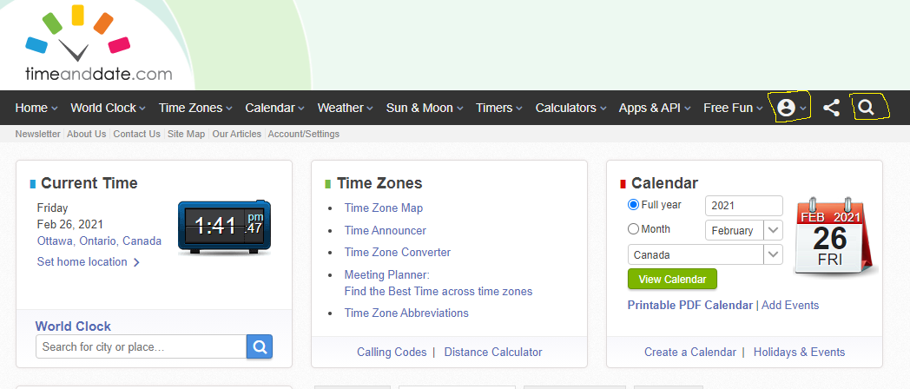

Figure #13: Small User Account Icon and Search Bar Icon

Improvements:

1. To help with being more accessible to more users, a more minimalistic design could help. Maybe a design layout that was less clustered and offered less options right on the main page. Being more minimalistic would meet the Neilson Heuristic of Aesthetic and Minimalist Design. In doing so, more users will find the website for usable as effectiveness may increase for some users. There is a potential trade off in efficiency, as reducing many options on the main page may also take away shortcut solutions for other users. More technical users didn’t have issues with the amount of information and may appreciate the number of quick shortcuts. Removing options may result in decreased satisfaction for these more technical users. Finding the right balance would be something worth looking into with a larger data set of participants.

2. Make it clearer to find important parts of the website such as user account and search bar (for the whole site). These two options exist on the main page but have two very small icons that link to the content which can go unnoticeable. For example, increasing the size of the search icon, or even creating a more noticeable search bar would give users, both new and frequent, more **flexibility and efficiency of use** to complete a task. Users could quickly search for specific items like meeting planners, business day calculators or related items, or even a help section for less technically inclined users. This would help meet the Flexibility and Efficiency of Use heuristic. This may also help with accessibility with users who have issues with vision. Ultimately, this will lead to the user being more effective and efficient at completing their task, increase user satisfaction, help keep users returning to the site and therefore increase usability.

Reflection on Process:

The experiment, for the most part, went as expected. Planning wasn’t an issue as I have friends I trust and can count on and arranging a meeting time for each participant happened quickly. Conducting the study went smoothly as the people I chose were professional and did their best to complete the tasks. Minimal instructions were required to complete the experiment.

If I were to do another study, I think I could spend more time thinking about ways to collect useful data. Wording/writing in general, and in this case for questionnaires, is not my strong suit and so I think I could have done better at coming up with more effective questions to gain useful data. Hypothetically, if there were to be a real-life study with many participants, then I think I would have approached it differently. Specifically, how I conducted the interview. With friends, as was the case in this study, I was able to be a little less formal as I knew what to expect from them. Certainly, with many diverse ranges of people and personalities and such, a different approach would be required when introducing them to a task for example, or briefing them on the experiment, etc.

Potential biases may have entered the study. For example, if I noticed a user struggling for a long time, I felt the need to offer help. While, initially, I was hesitant, I began to think of creative ways to offer hints to help them. When hints were offered to participants upon request, potential information may have been revealed that shouldn’t have been. An example of this being P1 during Task #2. The participant used the Windows PC calendar to calculate 32 business days ahead. After watching this take place for a minute and watching the incorrect solution result, I suggested how maybe the website could help calculate this information. I used the word calculate, which then clued the participant into using a calculator, which they may not have thought of using without the hint. Another bias could be P1 performing the experiment after work – we work together. This was the best time for this individual, but we were both a bit tired. Fatigue may have played a role in the results. As well, P3 forget their reading glasses and made note of that in the beginning, but it appears to not have played a significant role in that participants results.

**Appendix A: Questionnaire Data**

**Participant #1:**

Q1: How clear was it to complete task #1?

Unclear Clear

1 2 3 4 5*

Q2: How clear was it to complete task #2?

Unclear Clear

1 2 3 4* 5

Q3: If you need to perform similar tasks (travel, time zone, weather check), can you see yourself using this website again?

Yes* or no.

Q4: Were there any words/phrases/icons that helped you understand what the website is about?

List the items.  
Name of website  
home page icon  
Date icon  
real time clock.

Q5: Would you say the layout and design was minimalistic?

Non-mini. Minimalistic

1 2 3 4* 5

Q6: If you felt unsure of what to do, was there any help or advice offered by the website?

Yes or no. N/A

Q7: Is there anything that you would change about the layout or the design of the website?

Open answer. Write an explanation.

Change user/account Icon to be more central to the front page of the website so new visitors are more likely to notice it first.

Q8: How satisfied were you with using the website?

Unsatisfied Satisfied

1 2 3 4 5*

Q9: On a scale of 1 to 10, how would you rate your technical skills?

6

**Participant #2:**

Q1: How clear was it to complete task #1?

Unclear Clear

1 2 3 4 5

3

Q2: How clear was it to complete task #2?

Unclear Clear

1 2 3 4 5

1

Q3: If you need to perform similar tasks (travel, time zone, weather check), can you see yourself using this website again?

Yes or no.

no

Q4: Were there any words/phrases/icons that helped you understand what the website is about?

List the items.

The title, pictures, search box and the categories

Q5: Would you say the layout and design was minimalistic?

Non-mini. Minimalistic

1 2 3 4 5

1

Q6: If you felt unsure of what to do, was there any help or advice offered by the website?

Yes or no.

no

Q7: Is there anything that you would change about the layout or the design of the website?

Open answer. Write an explanation.

“Meeting planner” needs to be noticeable.

Q8: How satisfied were you with using the website?

Unsatisfied Satisfied

1 2 3 4 5

2

Q9: On a scale of 1 to 10, how would you rate your technical skills?

4

**Participant #3:**

Q1: How clear was it to complete task #1?

Unclear Clear

1 2 3 4 5

Q2: How clear was it to complete task #2?

Unclear Clear

1 2 3 4 5

Q3: If you need to perform similar tasks (travel, time zone, weather check), can you see yourself using this website again?

Yes or no.

Q4: Were there any words/phrases/icons that helped you understand what the website is about?

List the items.

Clock, calendar. timeanddate

Q5: Would you say the layout and design was minimalistic?

Non-mini. Minimalistic

1 2 3 4 5

Q6: If you felt unsure of what to do, was there any help or advice offered by the website?

Yes or no.  
  
Bullet titles.

Q7: Is there anything that you would change about the layout or the design of the website?

Open answer. Write an explanation.

no

Q8: How satisfied were you with using the website?

Unsatisfied Satisfied

1 2 3 4 5

Q9: On a scale of 1 to 10, how would you rate your technical skills?

7

**Appendix B: Observation Notes**

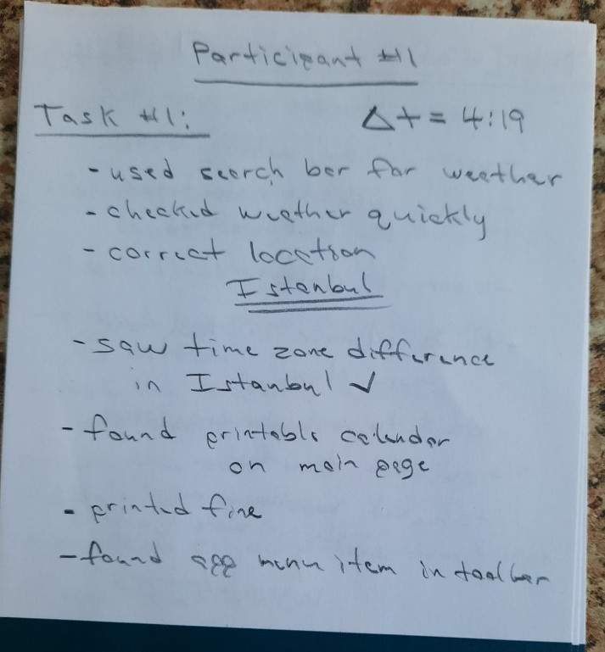

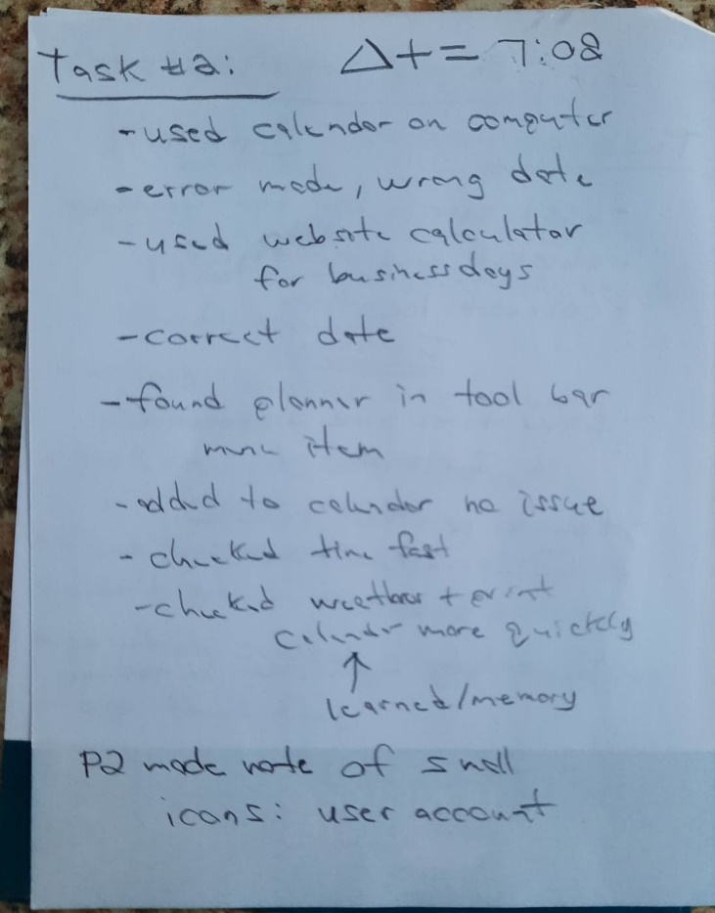

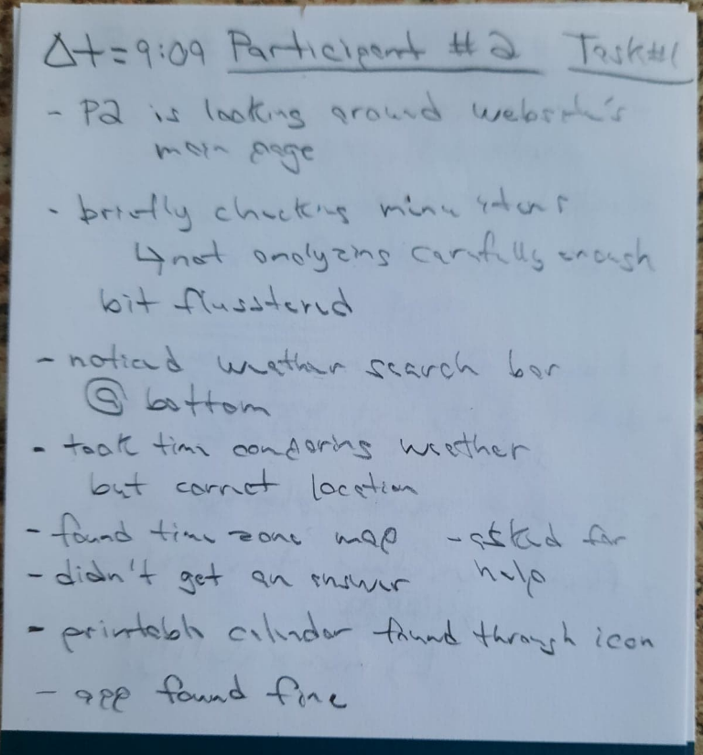

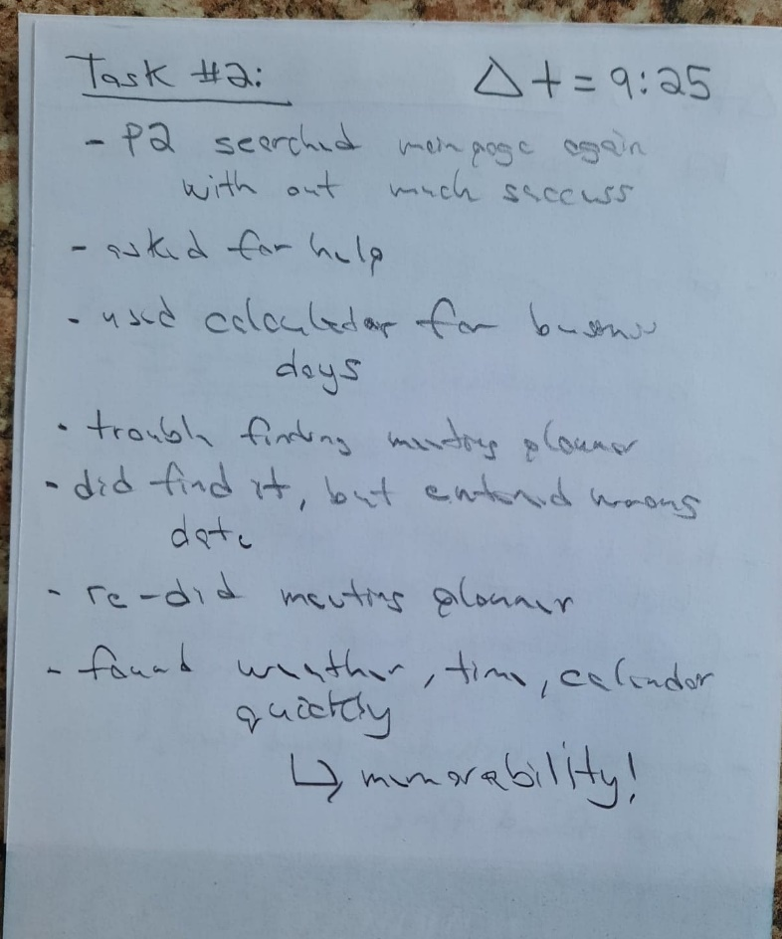

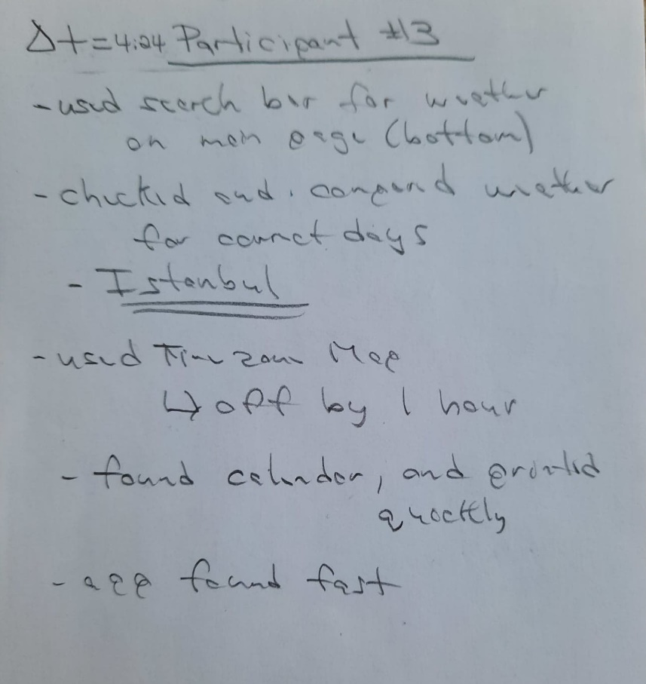

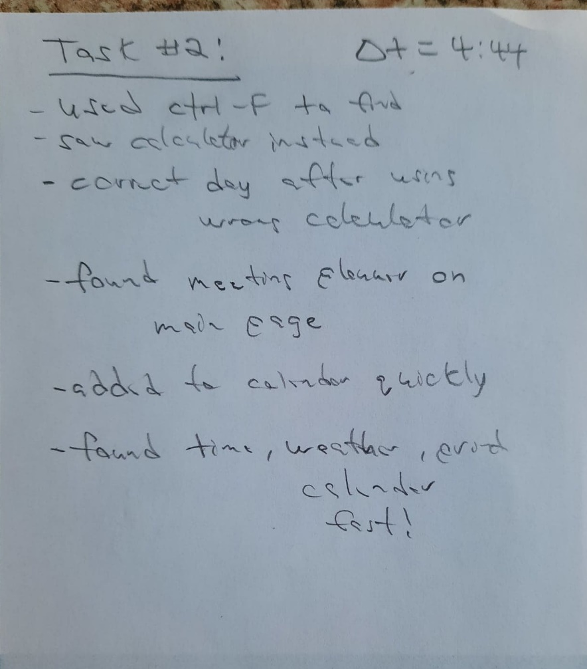

**Appendix C: Consent Forms**

P1:

All research data, including the audio-recording and electronic notes will be password-protected. When the analysis is completed, any paper copies of data (including any handwritten notes) will be kept as securely as possible by the researcher. Data will only be accessible by the researcher and the research supervisor.

Since this is part of a class project, data will be kept until the end of the course. All data will be securely destroyed by **June 2021.** Electronic data will be deleted, and paper copies will be shredded.

This project was reviewed and cleared by the Carleton University Research Ethics Board-B (CUREB-B Clearance #114528). If you have any ethical concerns with the study, please contact Carleton University Research Ethics Board (by phone at 613-520-2600 [ext. 4085] or by email at ethics@carleton.ca).

**Researchers’ contact information: Supervisor contact information:**

Steven Rhodes Prof. Sonia Chiasson

School of Computer Science School of Computer Science

Carleton University Carleton University

Email: steverhodes@cmail.carleton.ca Email: Chiasson@scs.carleton.ca

I agree to participate in this user study: __✓__ Yes _____ No

I agree to be video-recorded: __✓__ Yes _____ No

(If you only want to be audio-recorded while video-conferencing, please turn off your camera)

**Logan Corkum** 2021/02/26

________________________ ______________

Signature of participant Date

**Research team member who interacted with the participant**

I have explained the study to the participant and answered any and all of their questions. The participant appeared to understand and agree. I provided a copy of the consent form to the participant for their reference.

Steven Rhodes 2021/02/22

______________________ ______________

Signature of researcher Date

P2:

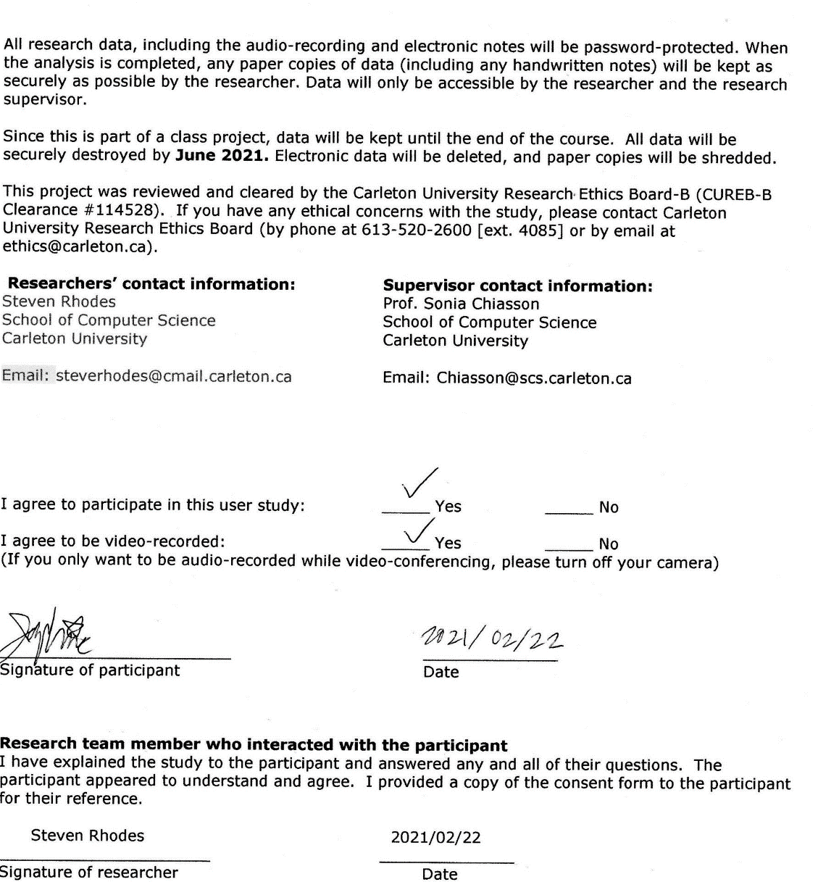

P3:

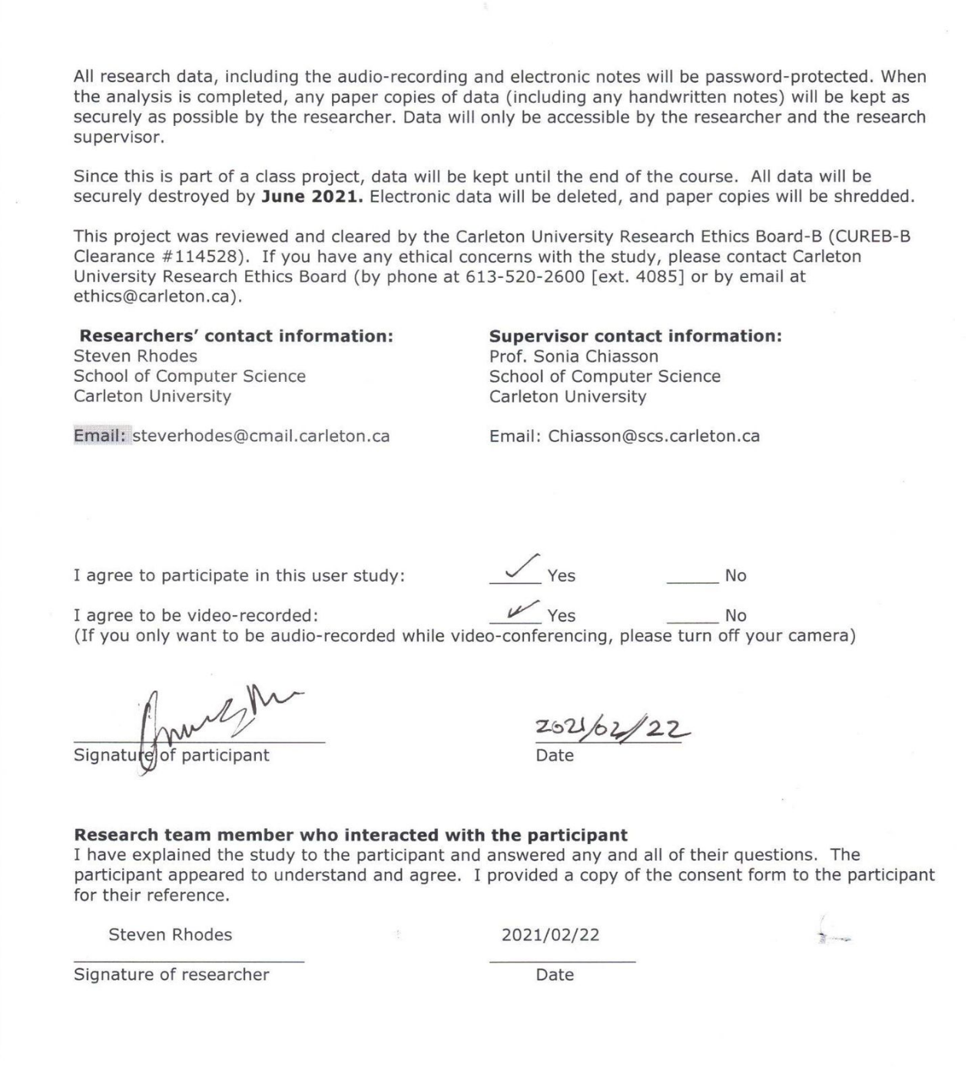

**Appendix D: Updated REB Protocol Form**



**Consent Form: Sample**

**NOTE: ITEMS IN RED WILL BE EDITED BY THE STUDENTS**

**Title**: COMP3008 Assignment 2 Project – ***Evaluating Website Usability Via User Study***

**Date of ethics clearance**: *October 2, 2020*

**Ethics Clearance for the Collection of Data Expires**: *September 30, 2021*

**Project clearance number:** CUREB-B Clearance # 114528

This project is being completed as part of COMP3008, an undergraduate course in Computer Science at Carleton University. This study aims to *assess the usability of a computer user interface.*

This project is about **testing the usability of a provided website with help from participants to gain data and use methods learned in class to come up with an evaluation.**

This study involves one session lasting approximately 20 minutes. During the session, you will be asked to *complete some tasks on a computer system, provide your opinion of the system, and offer feedback. Data may be collected through observation, questionnaires, interviews, or tools to measure user actions on the interface (e.g., timing information).*

If you provide explicit consent at the end of this form, the researcher will audio-record this session to help with note-taking, so that they can more fully converse with you. The audio recording will only be used for this purpose, and it will only be heard by the researcher. If using video-conferencing, you may turn off your camera. The interviewer will inform you before starting to record. If you do not wish to be audio-recorded, the researcher will take written notes of your comments instead.

Your data will be kept confidential and none of your personal accounts or data will be accessed. In reporting, it will be associated with an anonymous username (e.g., P1, P2).

Participation is completely voluntary. There is no obligation to participate. There is no compensation if you do choose to participate.

You have the right to end your participation in the study at any time, for any reason, up until the end of the session. To withdraw, simply tell the researcher; no reason or explanation is necessary. If you withdraw from the study, all information you have provided will be immediately destroyed. Withdrawal after the study session is not possible.

Most sessions will be completed remotely by video-conference. If you chose to video-conference, you and the researcher will agree on a mutually convenient platform. These platforms may have servers in countries outside of Canada and any data transmitted through them are subject to the laws of their respective countries. For example, Skype and Zoom have servers in the US and would be subject to US law.

If it is safe for you to do so (e.g., you live with the person conducting the session), you may complete the user study session in-person.

All research data, including the audio-recording and electronic notes will be password-protected. When the analysis is completed, any paper copies of data (including any handwritten notes) will be kept as securely as possible by the researcher. Data will only be accessible by the researcher and the research supervisor.

Since this is part of a class project, data will be kept until the end of the course. All data will be securely destroyed by **June 2021.** Electronic data will be deleted, and paper copies will be shredded.

This project was reviewed and cleared by the Carleton University Research Ethics Board-B (CUREB-B Clearance #114528). If you have any ethical concerns with the study, please contact Carleton University Research Ethics Board (by phone at 613-520-2600 [ext. 4085] or by email at ethics@carleton.ca).

**Researchers’ contact information: Supervisor contact information:**

Steven Rhodes Prof. Sonia Chiasson

School of Computer Science School of Computer Science

Carleton University Carleton University

Email: steverhodes@cmail.carleton.ca Email: Chiasson@scs.carleton.ca

I agree to participate in this user study: _____ Yes _____ No

I agree to be video-recorded: _____ Yes _____ No

(If you only want to be audio-recorded while video-conferencing, please turn off your camera)

________________________ ______________

Signature of participant Date

**Research team member who interacted with the participant**

I have explained the study to the participant and answered any and all of their questions. The participant appeared to understand and agree. I provided a copy of the consent form to the participant for their reference.

Steven Rhodes 2021/02/22

______________________ ______________

Signature of researcher Date

**Email/Social Media Sample invitation**



Hello,

I am looking for volunteers for a user study. This study is part of COMP3008: Human Computer Interaction, an undergraduate Computer Science course at Carleton University taught by Prof. Sonia Chiasson.

My project is about **testing the usability of a given website using a user study.**

The session will last approximately 20 minutes, and it can be done remotely. During the session, you will be asked to complete some tasks on a computer system, provide your opinion of the system, and offer feedback about your experience.

Participation is completely voluntary. You will not be compensated if you do choose to participate. There is no obligation to participate.

If interested in participating, please contact **steverhodes@cmail.carleton.ca**

This project was reviewed and cleared by the Carleton University Research Ethics Board-B (CUREB-B Clearance #114528). If you have any ethical concerns with the study, please contact Carleton University Research Ethics Board (by phone at 613-520-2600 [ext. 4085] or by email at ethics@carleton.ca).

**Appendix E: Signature**

I was having issues signing the REB protocol form and I don’t have a printer. Here’s my signature just in case.

